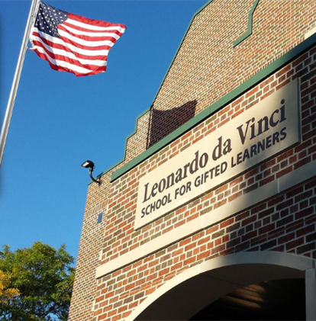

MINIMUM CAPACITY :-

The Minumum intake capacity

of students is between 150-350

children

LIBRARY :-

The Libarary is Available.

CANTEEN:-

The Canteen Facility is Available.

BOARDING :-

No availablility of boarding.

SPORTS :-

There are different categories

sports available.

Girls Volleyball

Boys Volleyball

Football

|  |  |  |
| --- | --- | --- |
| LEONARDO DA VINCI HIGH SCHOOL BUFFALO - SCHOOL |  |  |
|  |  |  |
| School Detail :- Leonardo da Vinci High School is a high school in the lower west side of Buffalo, New York. There are 400 students enrolled in da Vinci spanning grades 9–12. The high school building is located on the D'Youville College campus. The school located at 334 Porter Avenue and serves Grades 9 through 12.  This school is above the state average in key measures of college and career readiness.Even at schools with strong college and career readiness, there may be students who are not getting the opportunities they need to succeed. |  |
|